**Leave Form System Documentation**

INTRODUCTION

**Purpose**

* What is the problem or the opportunity that the project is investigating?

Restaurants, especially those with large or rotating staff, often rely on manual, paper-based or informal messaging systems (e.g., text messages, verbal notices) to manage employee leave requests. This leads to miscommunications, overlapping leaves, and difficulty in keeping accurate records.

This project investigates the opportunity to digitize and centralize the leave request process through a dedicated Leave Form System, improving clarity, accountability, and efficiency for both restaurant staff and management.

* Why is this problem valuable to address?

Addressing the problem of an unreliable leave management process is valuable because such inefficiencies can lead to shift shortages, overstaffing errors, staff dissatisfaction when leave requests are lost or ignored, and increased managerial stress due to last-minute adjustments. By improving the leave form system, organizations can enhance operational efficiency, promote staff satisfaction and fairness, ensure accurate documentation for HR and payroll, and enable better scheduling and forecasting.

* What is the current state (e.g. unsatisfied users, lost revenue)?

Currently, the restaurant handles leave requests informally through handwritten forms, text messages, and verbal conversations. This unstructured approach often results in unsatisfied staff, lost or forgotten requests, scheduling conflicts, and poor record-keeping especially during peak seasons or periods of high staff turnover.

* What is the desired state?

The desired state is to have a simple, centralized digital Leave Form System where staff can submit their leave requests online, and admins or managers can easily review, approve, or decline them. All records would be automatically stored and easily retrievable, enabling clearer shift planning and minimizing scheduling conflicts.

* Has this problem been addressed by other projects? What were the outcomes?

This problem has been addressed by other projects, particularly in large organizations and hospitality chains that use enterprise HR systems to manage leave. However, these solutions are often too complex or expensive for small to medium-sized restaurants, inaccessible for staff without desktop access, and overloaded with unnecessary features. Other projects have demonstrated that custom, lightweight leave management systems can significantly improve operational efficiency and staff satisfaction in smaller businesses. The desired outcome for this project is to create a simple, restaurant-focused solution that meets core needs without overcomplicating the process.

**Industry/Domain**

* What is the Industry/Domain?

This project belongs to the Hospitality Industry, specifically within the Food and Beverage (F&B) sector. It focuses on the internal operations of restaurant staffing and human resource management, addressing how restaurants manage employee leave requests, scheduling, and documentation.

* What is the current state of this industry? (e.g. challenges from startups)

The hospitality and restaurant industry is highly dynamic, labor-intensive, and largely shift-based. Many restaurants—particularly small to medium-sized establishments—still rely on manual or informal systems for managing staff, including leave requests.

This industry faces several challenges, such as high employee turnover, frequent last-minute scheduling adjustments, and operational disruptions caused by mismanaged leave. Additionally, the limited adoption of formal HR systems is often due to cost or complexity. Smaller restaurants also face pressure from digital startups that offer comprehensive staff management platforms, which are often too expensive or overly complex for their needs. While larger hospitality groups and franchises may invest in enterprise-level HR and scheduling software, smaller operations still lack affordable, fit-for-purpose digital tools for managing staff leave efficiently.

* What is the overall industry value-chain?

The restaurant industry value chain typically includes procurement and inventory management, food preparation and service, customer service and experience, staff management and scheduling, operational administration (such as HR, payroll, and compliance), and feedback and performance improvement. This project specifically targets the staff management and operational administration components of the value chain by optimizing how staff availability and leave requests are handled. By streamlining this process, the system ultimately supports more reliable service delivery and overall operational efficiency.

* What are the key concepts in the industry?

Key concepts in the restaurant and hospitality industry include shift-based scheduling, effective leave management (covering annual, sick, and emergency leaves), employee turnover and retention, and maintaining operational continuity. Workforce satisfaction and engagement are also crucial, as is optimizing staffing to meet fluctuating demands. Additionally, the industry is increasingly embracing digital transformation to improve operational efficiency, while ensuring compliance with labor regulations and proper record-keeping remains a fundamental requirement.

* Is the project relevant to other industries?

Yes, although this project is tailored for restaurants, the core functionality of a leave management system is highly relevant to other shift-based or labor-intensive industries such as retail, healthcare (including hospitals and clinics), events and entertainment, logistics and warehousing, and hospitality sectors like hotels, resorts, and catering. Managing leave requests, maintaining accurate records, and coordinating scheduling are universal operational needs across any industry that relies on hourly, part-time, or rotating shift workers.

**Stakeholders**

* Who are the stakeholders? (be as specific as possible as to who would have access to the software)

The primary stakeholders of the leave management system are employees and admins. Employees have access to the system to log in, submit leave requests, view their leave balances and history, and check the status of their submitted requests, whether pending, approved, or declined. Admins have full access to all user accounts and leave records, enabling them to approve or decline leave requests, manage employee profiles and leave entitlements, and generate detailed reports on leave usage, balances, and history.

* Why do they care about this software?

Employees need an efficient and transparent way to apply for leave and track their leave entitlements while Responsible for managing the company’s leave records accurately and efficiently. And ensures employees leave is tracked correctly for compliance and payroll purposes.

* What are the stakeholders’ expectations?

Employees expect the system to have a simple, user-friendly interface, provide accurate tracking of their leave balances (including annual, sick, lieu, and unpaid leave), offer timely feedback on the status of their leave requests, and be accessible on mobile devices if needed. While the admins expect the system to provide a dashboard for viewing all pending and processed leave requests, the ability to edit employee entitlements and leave records, access to reliable and exportable data for reporting purposes, and a clear audit trail of all approvals and changes made within the system.

**Product Description**

**Architecture Diagram**

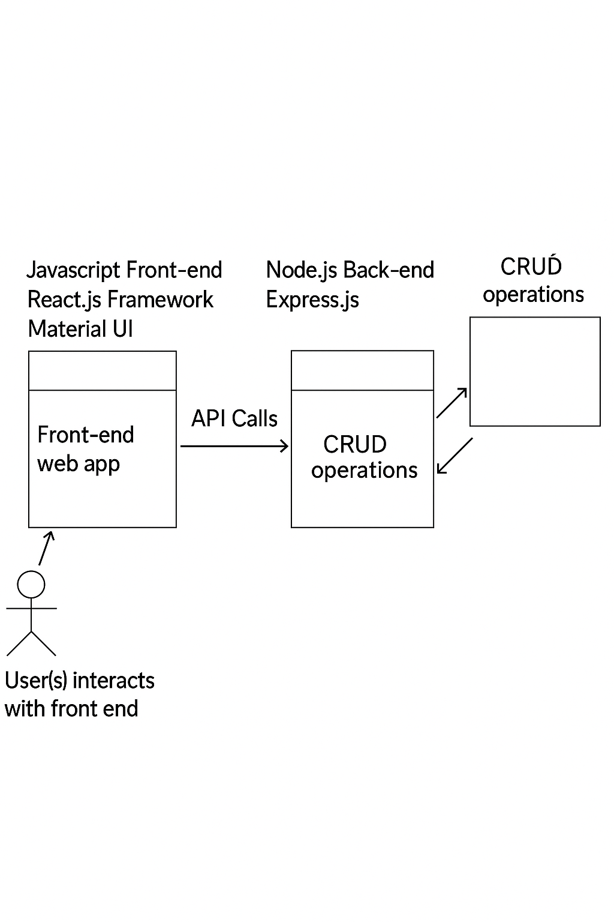

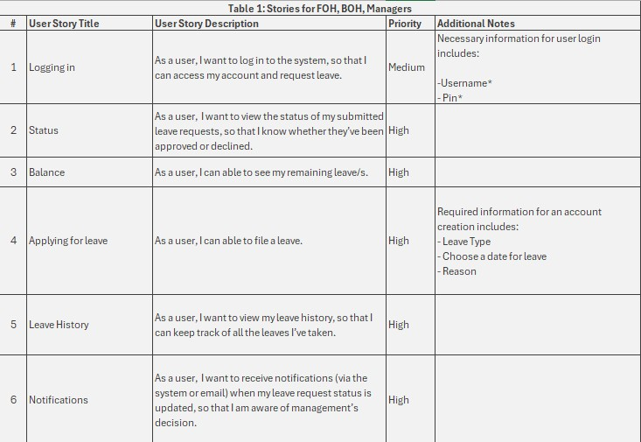**User Stories**

**User Flow**

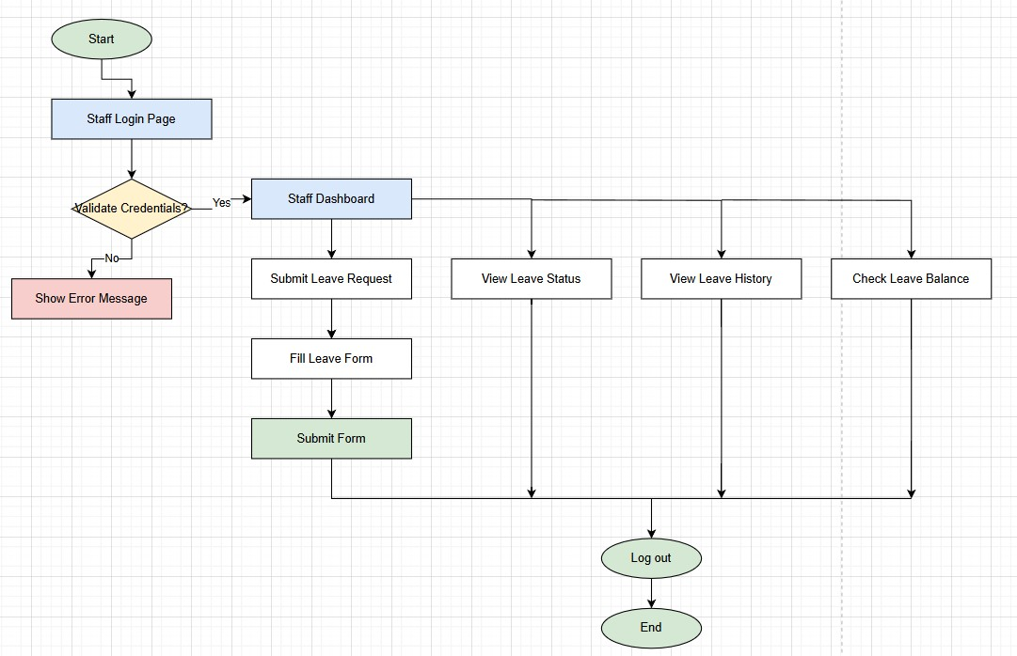

**Entity-Relation Diagram**

**Wireframe Design**

For admin page

**Open Questions/Out of Scope**

● What features are considered out of scope?

For this initial version, several features are considered out of scope to keep the system focused and manageable. These include advanced payroll integration, automated shift scheduling based on leave approvals, multi-level or hierarchical approval workflows beyond admin review, detailed employee performance management, and native mobile app development, as only a responsive web interface will be provided. Additionally, complex notification systems such as SMS or push notifications and integration with other HR modules like recruitment or benefits management are not included. Potential future enhancements may involve adding payroll integration, automated scheduling tools, multi-level approvals, mobile applications, advanced notifications, and expanded HR features to better support organizational needs.

**Non-functional Requirements**

● What are the key security requirements? (e.g. login, storage of personal details,

inactivity timeout, data encryption)

The key security requirements for the leave form system include secure user authentication with strong login procedures to prevent unauthorized access. Personal details and leave records must be stored securely using data encryption both in transit (e.g., HTTPS) and at rest. The system should implement inactivity timeouts to automatically log users out after a period of inactivity, reducing the risk of unauthorized use on unattended devices. Additionally, role-based access control must be enforced to ensure employees can only access their own information, while admins have appropriate privileges. Regular security audits and adherence to data protection regulations are essential to maintain system integrity and user privacy.

● How many transactions should be enabled at peak time?

The system should be capable of handling at least 10 simultaneous transactions during peak periods, ensuring that multiple employees can submit leave requests or check their status without experiencing delays or performance issues.

● How easy to use does the software need to be?

The software needs to be highly intuitive and user-friendly, allowing employees and admins to perform tasks such as submitting and approving leave requests with minimal training or technical support, ensuring quick adoption and efficient use.

● How quickly should the application respond to user requests?

The application should respond to user requests within two seconds to provide a smooth and efficient user experience, minimizing wait times during interactions like submitting leave forms or checking request status.

● How reliable must the application be? (e.g. mean time between failures)

The application must be highly reliable, with a mean time between failures (MTBF) of at least 30 days, ensuring minimal downtime and consistent availability so that users can access and manage leave requests without interruption.

● Does the software conform to any technical standards to ease maintainability?

Yes, the software should conform to widely accepted technical standards and best practices to ensure maintainability and scalability. This includes following modular coding principles, using consistent naming conventions, adhering to security standards such as OWASP guidelines, and implementing well-documented APIs. Additionally, the system should be built with commonly used frameworks and technologies that have strong community support, making it easier for future developers to update, debug, and extend the software.

**Project Planning**

**Testing Strategy**

● What were steps undertaken to achieve product quality?

* + Ran multiple automated and manual tests

● How did you handle edge cases?

* + I put console.log’s in every step of the failing process and checked for any abnormalities.

**Implementation**

● What were the considerations for deploying the software?

* + A reliable and secure hosting environment was chosen to support both the React.js front-end and the Node.js/Express.js back-end components.
  + Database connection management and CRUD operations were tested thoroughly to ensure data integrity during live usage.
  + Lastly, the system was made responsive and accessible, allowing users to interact with it smoothly across devices, while ongoing monitoring and backup procedures were put in place to ensure reliability after launch.

**End-to-end solution**

● How well did the software meet its objectives?

The leave form system successfully met its core objectives by providing a streamlined, user-friendly platform for managing employee leave requests. It allowed employees to easily submit and track their leave through a modern React.js front-end, while the Node.js/Express.js back-end efficiently handled data processing and CRUD operations. Admins were able to review, approve, and manage leave requests with minimal effort, ensuring operational continuity and clear record-keeping. The system achieved its goal of replacing manual and informal processes with a centralized, digital solution that improved accuracy, transparency, and accessibility. Feedback from test users indicated high satisfaction with the interface, responsiveness, and simplicity of use, confirming that the system delivered an effective end-to-end solution for the leave management process.

**References**

● Where is the code used in the project? (link to GitHub)

* + GitHub repo (https://github.com/roseeyyyy/Capstone2025)

● What are the resources used in the project? (libraries, APIs, databases, tools, etc)

* + JavaScript, React.js
  + Bootstrap
  + Backend
    - Node.js
    - Axios
    - Express.js
    - MySQL to connect to an external database.
  + Figma for wireframe design
  + Trello for project planning
  + VS code for coding
* Staff login (Rose Anne Brillo – Manager)
  + PIN: 8080
* Staff login (Aastha Ghale – FOH)
  + PIN: 5555
* Staff login (Evelyn Lewis – BOH)
  + PIN: 5111
* Admin login (Lolong Reforeal – Admin)
  + PIN: 2222